**Homework for General physics Set4-Answers**

1. For a TTL periodic pulse with duty cycle of 50%, it is a pulse with period of , fundamental frequency , within one period: 

It repeats this pattern over periods. Find the Fourier Expansion series for this TTL pulse.

Answers:

A similar pulse is given in Notes as well as Hecht’s (section 7.3, pg. 305)

If we shift down this pulse by 1/2 and times 2, we get same pulse in the book. We already know the F-expansion series there.



 (Calculation is in Hecht’s)



Of course you can do the honest calculation to find the expansion coefficients too.

2. Hecht’s 7.36

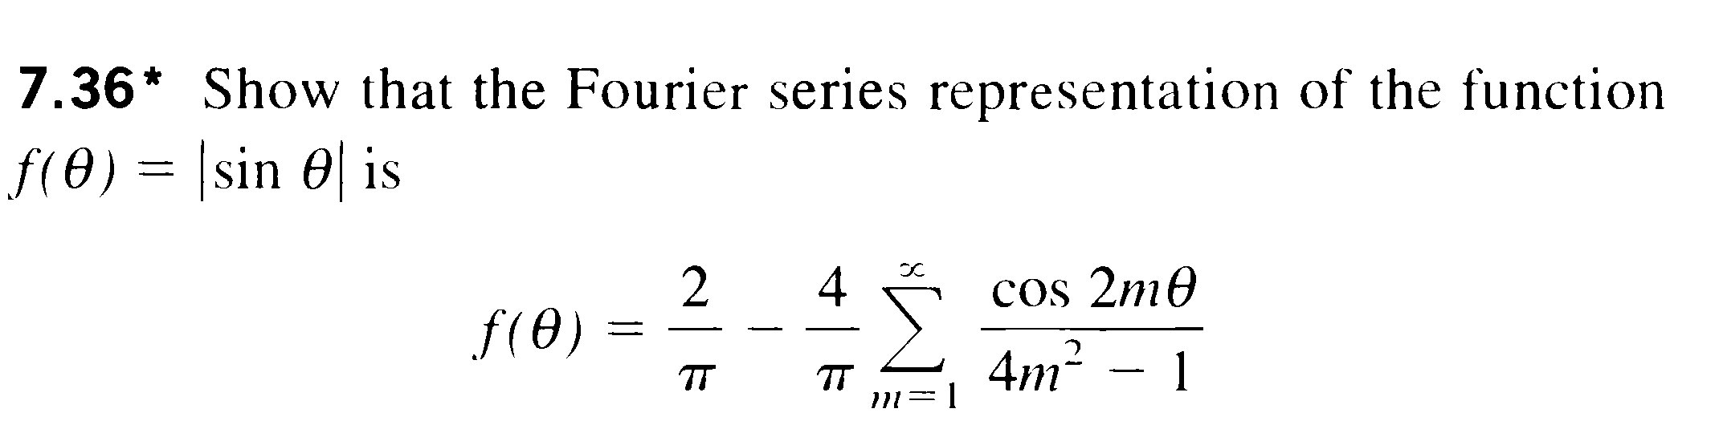

Answer:

The period is between for ; For the  its period is actually between , (period) and in this period ,

Fundamental frequency is , and it’s an even function so the expansion does not have sine terms:



 ,

 which is the DC term

For other m=1,2… (AC terms):









Of course you may also take period of  as :

and calculate ( a bit more complicated than above) to get same expansion.

3. For periodic function, within a period of , its form is:



It repeats itself over other region. Find its Fourier Expansion and prove a famous math relation:  (which is a part of Riemann zeta function)

**Answer:**

This is an even function, so only the DC and cosine terms. 





 Here I use the fact the integrand is even.

You may check integral table or calculate the integral yourself (by integration by parts…)





For the Riemann Zeta function, we take  and insert into above:



We have:



Thus: 

4. For a triangular periodic wave represented by (within one period):







Find its Fourier Expansion.

Answer:

Even function, only DC and cosine terms, 

The details on calculation of coefficients are skipped here, the answer is:



5. In my note and Zhao’s book, we use the convention that for function f(x) and its Fourier Transform F(K), their relations are:



However, this is not the universal convention, you will find in Hecht’s book, he defines:



Of course there is a relation between the Fourier Transforms defined by above conventions (I chose F’ as function form of Fourier Transform in Hecht’s convention, while he just uses F), prove that:

, i.e. the Fourier Transform used by Hecht is just our Transform with –K (the function flipped over K axis)

Answer:

Intuitively, the relation is kind of obvious, the K in one convention is just –K in another, the math derivation is :



We take a substitution with , the F’ in Hecht’s convention is then



But the right side is just the Fourier transform F in our convention, thus:



So knowing the F in one convention, we can get the transform in another convention easily. In this course, I shall stick to my convention.

6. 1) For a square function with height A width (A, *a* are constants), and zero elsewhere:



Find its Fourier transform (spectrum) F(K)

2) For a truncated cosine function with duration of *a*, i.e.



It is basically a cosine function times the above square function. (Of course here instead of x, we use t; instead of K we will use )

Find the Fourier transform for the above truncated cosine function 

Answer:

1) This is a calculation we had done several times before though not in context of Fourier transform, the answer would be a sinc function:



This answer can also compare with transforms of some common functions in Zhao’s book, pg. 91 (Vol.2)

Where we have  due to our symmetric convention (you times  to Zhao’s result to get answer in our convention for F(K)) ; and we use angular frequency K while Zhao uses frequency f, . With these in mind, you will find our answer agrees with Zhao’s.

2) Direct calculation and use 



The integral is same as last problem just replace K with etc.

i.e.: 





The spectrum (I mean the F) is just two shifted sinc functions centered around 

Same result as in Zhao’s table, pg. 92 (except the  factor due to convention).

Later when we learned convolution theorem in Fourier Transform, we can get the above answer more quickly.

(Here is just an outline, skip it if you want to: The original function is the product of cosine and square function, its F-transform would be convolution of the transform of cosine (which is delta function) convolves with transform of square function(which is sinc function). The convolution between delta function with other function, as we shall see will shift the function to the center of the delta function)

7. Starting from our basic formula for Fourier Transform, we study transforms for even and odd f(x).

1) If f(x) is an even function f(x)=f(-x), prove that:



This is called Fourier Cosine transform for even functions (analogy to Fourier expansion for even periodic functions only contains cosine terms)

2) If f(x) is an odd function, f(x)=-f(-x), prove that:

 where 



Answer:

1)  using Euler formula for 

Since f(x) is an even function, the f(x)sinKx would be odd and integration over symmetric space would vanish. So the non-zero term is just (also F(x)cosKx is even, so integral from –A to +A is just twice the integral from 0 to A):



Here notice **F(K) is an even function for K**, if you replace K with –K, above integral is same, then:



Similar argument will show: 

2) The proof follows exactly same procedure, using the fact f(x) is odd, then f(x)sinKx would be even, and f(x)cosKx would be odd.

8. Hecht’s 11.8:

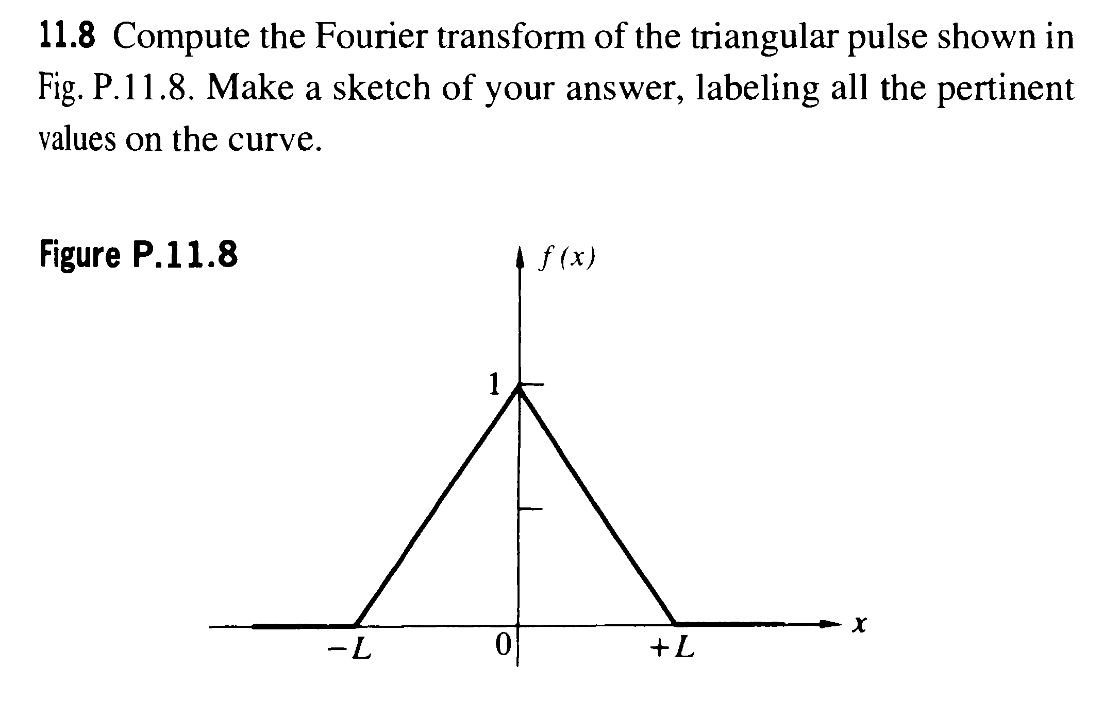

The function is:  for x is between (0, L); and  for x is between (-L,0); 0 elsewhere.

(Note: Hecht’s is at solution section, Zhao’s result on pg. 94 has a mistake: should be; both answers differ from our definition of F(K) by a constant factor . Needless to say this problem is asking you to do the dirty work of calculation instead of copying answers from books. You may check the integration table for integrals)

Answer:

You may directly using basic formula, doing integral over –L--0 and 0—L with the given f(x) form.

Here I use the results in last problem and save me some calculation.

The function is even, so I can do the integral as:



First part of integrand: 

Second part: 

I check the table for integral ( indefinite integral form), then:



Combine all above, the sinKL terms will be canceled and the final result is:



9.



